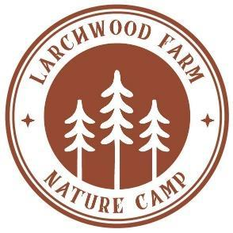
Funding Opportunities

For Families with a Child with Special Needs

Ontario Autism Program (OAP)
The Ontario Autism Program provides funding to purchase services and support for children diagnosed with autism spectrum disorder (ASD). These funds can be used to cover occupational therapy services and summer camp programs.
Click here to learn more and to register for the program.

One-to-One Summer Support Worker Reimbursement Fund
Autism Ontario’s One-to-One Summer Support Worker Reimbursement Fund provides funding for children diagnosed with ASD to subsidize the costs of retaining a one-to-one support worker or sending a child to summer camp. Maximum amount that can be claimed is $600 for the months of July and August. Must apply between May 1, 2023 to May 31, 2023. Successful candidates are randomly selected by June 9, 2023 and will be informed via email. Reimbursement will be issued through Autism Ontario and receipts must be submitted before September 15, 2023.
Click here for more information.

Special Services at Home (SSAH)
The Special Services at Home program provides funding for services and supports, including summer camp programs and one-to-one support workers, for children with developmental and/or physical disabilities.
Click here to learn more and to access the application form.

Extended Health Insurance
Some extended health insurance plans cover occupational therapy services up to a maximum amount. Click here for a sample letter that you can send to your employer or insurance company requesting occupational therapy coverage if your insurance policy does not already cover this service. Under the “Extended health insurance” section see links for sample “Letter to my employer” and “Letter to my insurance company.”

For Families in Need of Financial Assistance

Canadian Tire Jumpstart Program
The Jumpstart program provides grants to low-income families to cover the costs associated with sport or physical activity. Funding can be allocated for sustained programs that involve sports or physical activity, such as 5+ week sports programs (with at least 1 session per week) or sports camps (with a minimum of 5 consecutive days). Funding can be up to $300 per activity with an annual maximum of $600 per child.
Click here to access the grant application.

Grey County Social Initiatives Funding (Recreation Subsidy)
The provides subsidies for recreation activities, including summer camp programs, for families who live in Grey County and have household earnings less than $70,000 per year. Subsidies are based on family gross income per year and applicants are required to pay for 10% of the total registration fee for the activity.
Click here to learn more and to access the application form through the YMCA website. See the section titled “Grey County Social Initiatives Funding (Recreation Subsidy)” under the “Other Financial Assistance Programs” heading.

Beaver Valley Outreach (BVO) Recreational Funding
Beaver Valley Outreach provides recreational funding for families who live in the Town of The Blue Mountains and whose household earnings are less than $40,000 per year. Funding can be used towards registration fees for swimming, music or art lessons, etc. and applicants are asked to pay 10% of the total cost for the activity. The maximum funding per child per year is up to $300.
Click Here to learn more and to access the application form.

